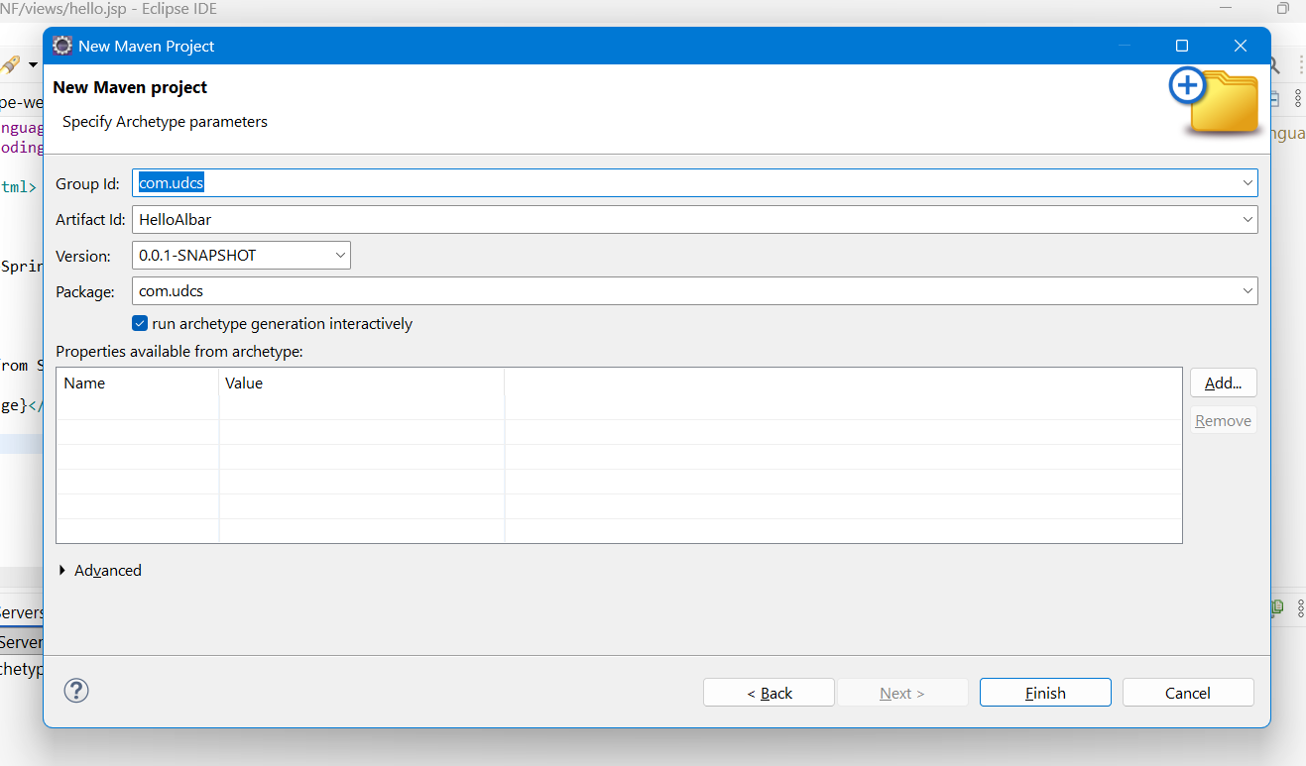
POM.xml cde:
<project xmlns="http://maven.apache.org/POM/4.0.0"
xmlns:xsi="http://www.w3.org/2001/XMLSchema-instance"
xsi:schemaLocation="http://maven.apache.org/POM/4.0.0 https://maven.apache.org/xsd/maven-4.0.0.xsd">

<modelVersion>4.0.0</modelVersion>

<groupId>com.udcs</groupId>
<artifactId>firstwebapp</artifactId>
<version>0.0.1-SNAPSHOT</version>
<packaging>war</packaging>

<properties>
<java.version>18</java.version>
<spring.version>5.3.39</spring.version>
<maven.compiler.source>18</maven.compiler.source>
<maven.compiler.target>18</maven.compiler.target>
</properties>

<dependencies>

<dependency>
<groupId>org.springframework</groupId>
<artifactId>spring-webmvc</artifactId>
<version>${spring.version}</version>
</dependency>

<dependency>
<groupId>javax.servlet</groupId>
<artifactId>javax.servlet-api</artifactId>
<version>4.0.1</version>
<scope>provided</scope>
</dependency>

<dependency>
<groupId>jstl</groupId>
<artifactId>jstl</artifactId>
<version>1.2</version>
</dependency>

</dependencies>

<build>
<plugins>

<plugin>
<groupId>org.apache.maven.plugins</groupId>
<artifactId>maven-compiler-plugin</artifactId>
<version>3.11.0</version>
</plugin>

<plugin>
<groupId>org.apache.maven.plugins</groupId>
<artifactId>maven-war-plugin</artifactId>
<version>3.4.0</version>
</plugin>

</plugins>
</build>

</project>
Step 3: Create web.xml
Location:
src/main/webapp/WEB-INF/web.xml
Step 4: Create spring-web-servlet.xml
Location:
src/main/webapp/WEB-INF/spring-web-servlet.xml.

Step 5: Create Java Source Folder
If it doesn't exist:
src/main/java
Step 6: Create Package
com.udcs
Step 7: Create HelloController.java
Location:
src/main/java/com/udcs
Step 8: Create Views Folder
WEB-INF
views
Step 9: Create hello.jsp
Location:
WEB-INF/views/hello.jsp
Step 10: Configure Tomcat
Window
→ Preferences
→ Server
→ Runtime Environments
→ Add
→ Apache Tomcat v9.0
Tomcat Directory:
C:\Apache\Tomcat9\apache-tomcat-9.0.120
JRE:
jdk-18.0.2
Finish.

Step 11: Run on Server
Right Click Project

Run As

Run on Server
Select
Tomcat v9.0 Server
Finish.

Step 12: Open Browser
http://localhost:8080/HelloAlbar/
Output:
Hello Albar

Verify the Context Path
In Eclipse:
- Go to the Servers view.
- Double-click Tomcat v9.0 Server at localhost.
- Under Modules, tell me:
  - What is the Path?
  - What is the Module name?

